WSpeedrun - Speedrunning platform

Backend microservices untuk platform speedrunning. Terdiri dari 3 service utama yang berjalan secara independen: Auth Service, Game Service, dan Runs Service.
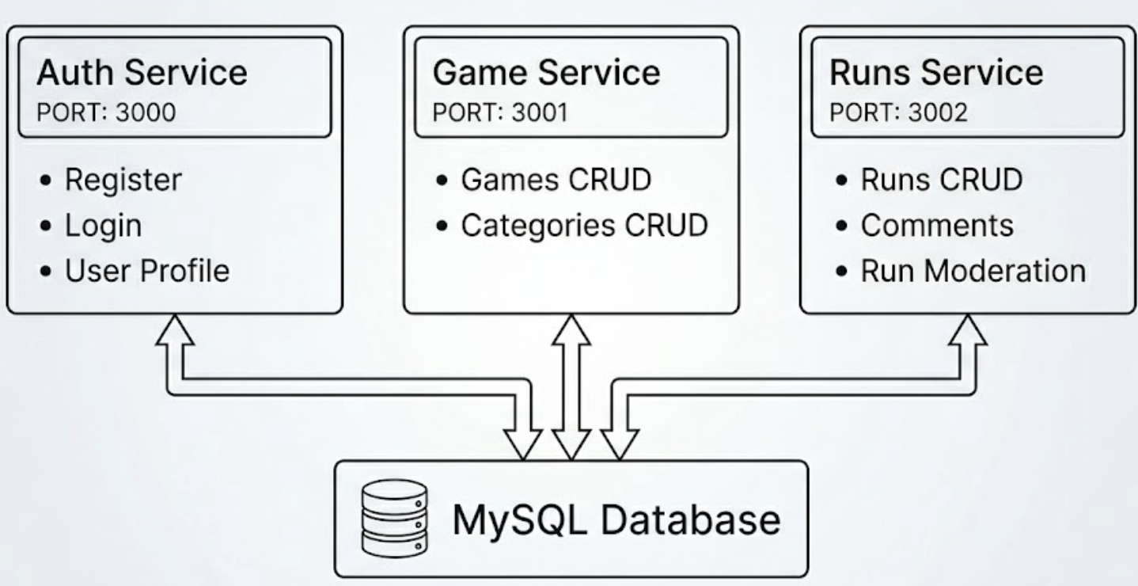

Runs Service melakukan HTTP fetch ke Game Service (localhost:3001) untuk validasi kategori sebelum menyimpan run baru.

Tech Stack
- Framework: NestJS (TypeScript)
- Database: MySQL
- ORM: Prisma
- Auth: JWT (passport-jwt)
- Password Hashing: bcrypt
- API Docs: Swagger (Game Service & Runs Service)

Features
AuthService
- login — cari user by email, compare bcrypt, return JWT
- register — cek duplikat email, hash password, insert user
- getProfile — ambil data user by ID, tanpa field password
GamesService
- getGames — ambil semua game
- getGameById — ambil 1 game + relasi categories-nya
- createGame — validasi field tidak kosong, insert game
- updateGame — update nama/deskripsi game
- deleteGame — hapus game by ID
- validateCategoryId — cek apakah category ID exist
CategoriesService
- getCategoriesById — ambil 1 kategori (endpoint ini juga yang di-fetch RunsService untuk validasi lintas service)
- createCategory — cek dulu game-nya ada, baru insert kategori
- updateCategoryDetail — update nama/game_id kategori
- deleteCategory — hapus kategori by ID
RunsService
- getRunsByCategory — fetch validasi ke Game Service dulu, lalu ambil run ACCEPTED sorted by durasi asc (leaderboard)
- getRunsByUser — kalau liat milik sendiri: semua status tampil. Kalau user lain: hanya ACCEPTED
- getRunById — ambil 1 run by ID
- createNewRunEntry — fetch validasi kategori ke Game Service, insert run dengan status PENDING
- getRunsByStatus — filter run by status, buat admin moderasi
- updateRunStatus — update status + set verified_at, dipakai accept/reject
CommentsService
- createNewComment — validasi user_id harus sama dengan yang login, insert komentar
- deleteComment — ambil komentar, validasi ownership, baru delete

Arsitektur Pattern
Microservices dengan HTTP Communication dimana setiap service punya database sendiri dan berjalan di port berbeda. Komunikasi antar service dilakukan via plain HTTP fetch

Client Request
l
▼
NestJS REST API
Controller → Guard → Service → Prisma → DB
l
▼
HTTP fetch (localhost)
l
▼
Service lain (validasi)

Layered Architecture (Controller → Service → Repository)

HTTP Request
│
▼
Controller ← handle routing, param/body extraction, guard
│
▼
Service ← business logic, validasi, orchestration
│
▼
PrismaService ← database access (Repository pattern via ORM)
│
▼
MySQL Database

Guard Chain (Authentication → Authorization)
Request
│
▼
JwtAuthGuard ← validasi JWT token, inject req.user = { userId, role }
│
▼
AdminGuard ← cek req.user.role === 'ADMIN'
(atau RolesGuard)
│
▼
Controller Handler

